Preliminary Research Questions:

1. List the top 3 and bottom 3 makers for the fiscal years 2023 and 2024 in terms of the number of 2-wheelers sold

**Top 3 Maker**

**with cte as(select maker,vehicle_category,sum(electric_vehicles_sold) as Total_vehicle_sold**

**from electric_vehicle_sales_by_makers**

**where vehicle_category="2-Wheelers"**

**group by maker),**

**FI as**

**(select fiscal_year from dim_date where fiscal_year="2023" and "2024")**

**select fiscal_year,vehicle_category,Total_vehicle_sold,maker from cte,FI**

**group by fiscal_year ,vehicle_category,maker**

**order by Total_vehicle_sold**

**limit 3;**

**with cte as(select maker,vehicle_category,sum(electric_vehicles_sold) as Total_vehicle_sold**

**from electric_vehicle_sales_by_makers**

**where vehicle_category="2-Wheelers"**

**group by maker),**

**FI as**

**(select 2023 from dim_date where fiscal_year="2023" and "2024")**

**select fiscal_year,vehicle_category,Total_vehicle_sold,maker from cte,FI**

**group by fiscal_year ,vehicle_category,maker**

**order by Total_vehicle_sold desc**

**limit 3;**

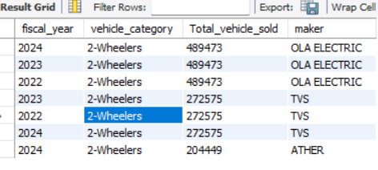

**Bottom 3 Maker:**

**with cte as(select maker,vehicle_category,sum(electric_vehicles_sold) as Total_vehicle_sold**

**from electric_vehicle_sales_by_makers**

**where vehicle_category="2-Wheelers"**

**group by maker),**

**FI as**

**(select fiscal_year from dim_date where fiscal_year="2023" or "2024")**

**select fiscal_year,vehicle_category,Total_vehicle_sold,maker from cte,FI**

**group by fiscal_year ,vehicle_category,maker**

**order by Total_vehicle_sold**

**limit 7;**

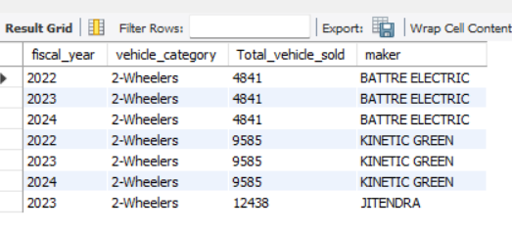

1. **Identify the top 5 states with the highest penetration rate in 2-wheeler and 4-wheeler EV sales in FY 2024.**

**with cte as**

**(select vehicle_category,state,round(sum(electric_vehicles_sold/total_vehicles_sold)*100,2)**

**as Penetration_Rate from electric_vehicle_sales_by_state**

**group by vehicle_category,state),**

**my_Ca as (select * from dim_date fiscal_year where fiscal_year=2024)**

**select vehicle_category,Penetration_Rate,fiscal_year,state from cte ,my_Ca**

**group by vehicle_category, Penetration_Rate,fiscal_year,state**

**order by Penetration_Rate desc**

**limit 6;**

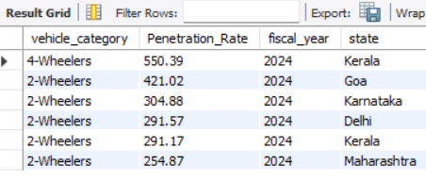

1. **List the states with negative penetration (decline) in EV sales from 2022 to 2024**

**with cte as**

**(select vehicle_category,state,round(sum(electric_vehicles_sold/total_vehicles_sold)*100,2) as Penetration_Rate**

**from electric_vehicle_sales_by_state**

**group by vehicle_category,state),**

**my_Ca as (select * from dim_date fiscal_year )**

**select vehicle_category,Penetration_Rate,fiscal_year,state from cte ,my_Ca**

**group by vehicle_category, Penetration_Rate,fiscal_year,state**

**order by Penetration_Rate**

**limit 10;**

**4. What are the quarterly trends based on sales volume for the top 5 EV makers (4-wheelers) from 2022 to 2024**

**with cte as(select maker,vehicle_category,sum(electric_vehicles_sold) as Total_vehicle_sold**

**from electric_vehicle_sales_by_makers**

**where vehicle_category="4-Wheelers"**

**group by maker),**

**FI as**

**(select quarter,fiscal_year from dim_date where fiscal_year="2023" and "2024")**

**select quarter,fiscal_year,vehicle_category,Total_vehicle_sold,maker from cte,FI**

**group by fiscal_year ,vehicle_category,maker,quarter**

**order by Total_vehicle_sold**

**limit 16;**

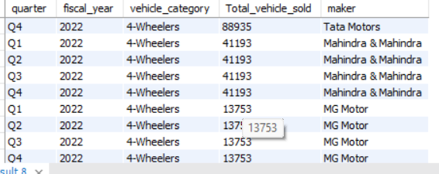

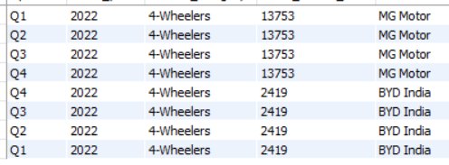

1. **How do the EV sales and penetration rates in Delhi compare to Karnataka for 2024?**

**select state,sum(electric_vehicles_sold) as Total from electric_vehicle_sales_by_state**

**where state="Delhi"**

**or state="Karnataka"**

**group by state**

**order by Total desc;**

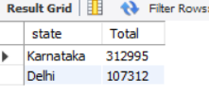

**8. What are the peak and low season months for EV sales based on the data from 2022 to 2024**

**Peak month:**

Select vehicle_category,EXTRACT(MONTH from ï»¿Record_Date) as peak_month,ï»¿Record_Date,sum(electric_vehicles_sold) as Total_vehicle_Sold

from electric_vehicle_sales_by_state

group by vehicle_category,ï»¿Record_Date

order by Total_vehicle_Sold desc

limit 1;



**low season:**

**select vehicle_category,EXTRACT(MONTH from ï»¿Record_Date) as peak_month,ï»¿Record_Date,sum(electric_vehicles_sold) as Total_vehicle_Sold**

**from electric_vehicle_sales_by_state**

**group by vehicle_category,ï»¿Record_Date**

**order by Total_vehicle_Sold**

**limit 3;**

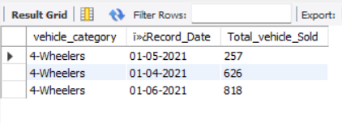

**10. Estimate the revenue growth rate of 4-wheeler and 2-wheelers EVs in India for 2022 vs 2024 and 2023 vs 2024, assuming an average unit price.**

**Total Vehicle Sold:**

**with revenue_changes as**

**(select fiscal_year,vehicle_category,sum(total_vehicles_sold) as Total_revenue,**

**lag(sum(total_vehicles_sold)) over(partition by fiscal_year order by vehicle_category ) as Previous_revenue**

**from electric_vehicle_sales_by_state join dim_date on electric_vehicle_sales_by_state.ï»¿Record_Date=dim_date.ï»¿Record_Date**

**group by vehicle_category,state,fiscal_year)**

**Select fiscal_year,vehicle_category,round(sum(((Total_revenue-Previous_revenue)/Previous_revenue))*100,0)As Estimate_Growth ,**

**lag (round(sum(((Total_revenue-Previous_revenue)/Previous_revenue))*100,0),2)over(order by fiscal_year ) as Estimate_growth_comaparison**

**from revenue_changes**

**group by fiscal_year,vehicle_category**

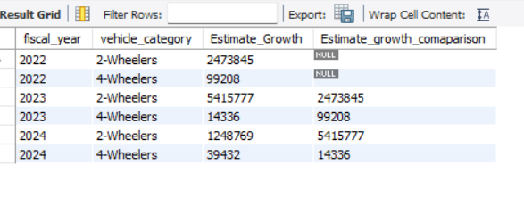

**Electrical Vehicle sold:**

**with revenue_changes as**

**(select fiscal_year,vehicle_category,sum(total_vehicles_sold) as Total_revenue,**

**lag(sum(total_vehicles_sold)) over(partition by fiscal_year order by vehicle_category ) as Previous_revenue**

**from electric_vehicle_sales_by_state join dim_date on electric_vehicle_sales_by_state.ï»¿Record_Date=dim_date.ï»¿Record_Date**

**group by vehicle_category,state,fiscal_year)**

**Select fiscal_year,vehicle_category,round(sum(((Total_revenue-Previous_revenue)/Previous_revenue))*100,0)As Estimate_Growth ,**

**lag (round(sum(((Total_revenue-Previous_revenue)/Previous_revenue))*100,0),2)over(order by fiscal_year ) as Estimate_growth_comaparison**

**from revenue_changes**

**group by fiscal_year,vehicle_category**

